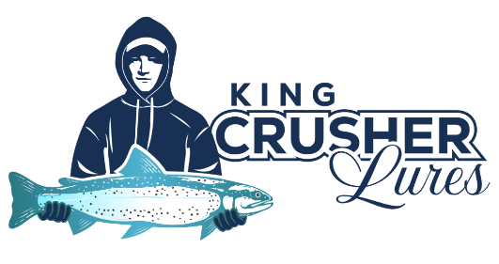
2026 LURE DESIGN CONTEST
COLOUR IT, NAME IT, BECOME A LOCAL LEGEND

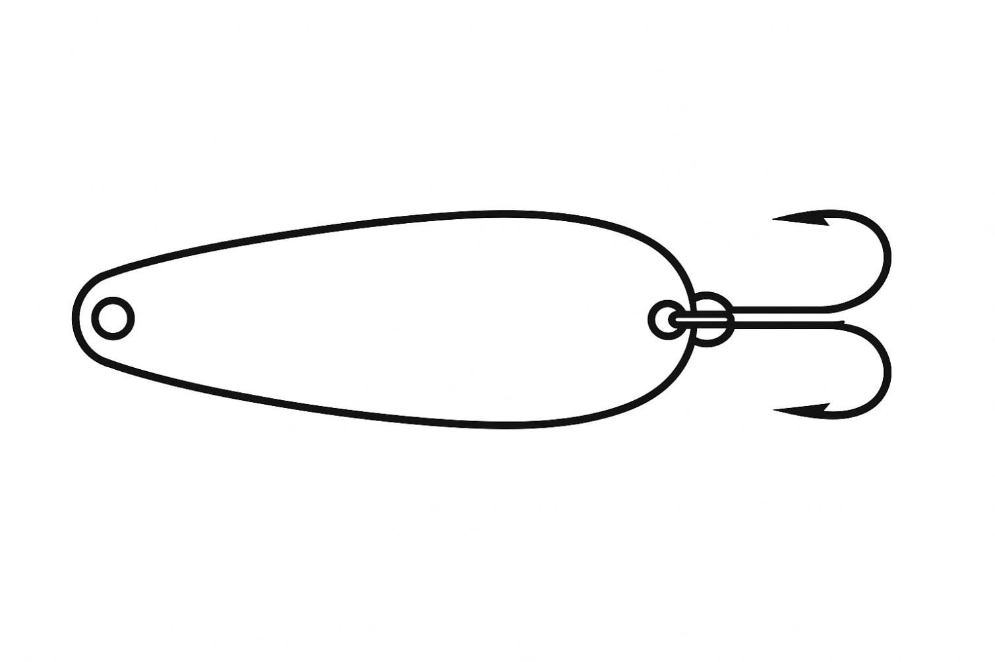

NAME OF LURE_________________________________________________

DESIGNED BY___________________________________________________

